- Introduction
The platform ecosystem is a good approach for companies to get external companies/individuals involved in their innovation. In this report, the platform ecosystem concepts are explained firstly, and then Amazon Alex and WordPress are given as two cases that use platform ecosystem to innovate. Subsequently there will be a discussion to check whether the concepts explained can be applied to the two cases.

- Platform Ecosystem
A platform is a designed ‘environment’[1] which is supported by a governance structure and an additional set of protocols or standardss .
The governance structure includes a set of protocols that determines who can participate, what roles they might play, how they might interact, and how disputes get resolved. For example, see the main players in a platform ecosystem below(Deloitte, 2015).

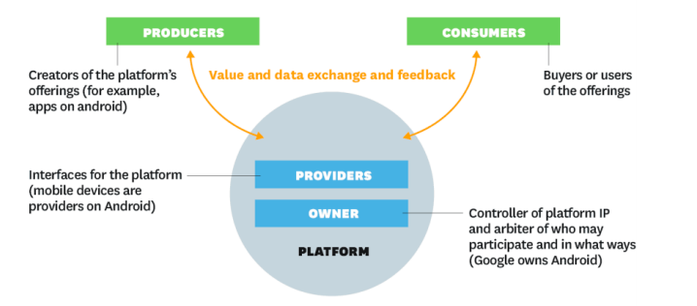
Figure1 The players in a platform ecosystem[2]
The additional set of protocols or standards is typically designed to facilitate connection, coordination, and collaboration(Deloitte, 2015).
Platform businesses bring together producers and consumers in high value exchanges. Their chief assets are information and interactions, which together are also the source of the value they create and their competitive advantage[2].
The information and interactions are implemented by layers of capabilities and standards(Deloitte, 2015) which constitute the foundation of the platform ecosystem and provide the standard interface for producers’ offerings to combine together to serve consumers.
For a company that adopts platform strategy, “network effects” is the central point. With network effects accompanied by the self-reinforcing cycle, if there are more producers and consumers participated in the platform, there will be more value about the platform: a wide range of products offered by producers meet the needs of different customer types.
There are different forms of platform businesses: Integrator Platform, Product Platform, Two-sided Platform. The Integrator Platform has the highest control, while the Two-sided Platform is the highest autonomy type for external innovators[3].
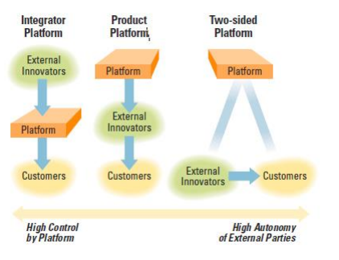
Figure2 The forms of Platform business[3]
In the Integrator platform, the platform is positioned between external innovators and customers, owning and controlling the interactions with customers [3]. In the Product platform model, external innovators develop products with the platform’s architecture and sell them to customers, the platform can control the external innovators through the architecture which is the core technology of the products. While for Two-sided platform model, external innovators and customers are able to directly transact with each other as long as they affiliate with the platform’s owner . The core technology of the products offered by external innovators is mastered by external innovators themselves[3].

- Case Study
3.1 Case Study 1: Amazon Alexa Ecosystem
Alexa is Amazon’s cloud-based voice service available on tens of millions of devices from Amazon and third-party device manufacturers. Alexa can help to build natural voice experiences that offer customers a more intuitive way to interact with the technology they use every day[4].
The Alexa ecosystem is open, and collection of tools, APIs, reference solutions, and documentation are provided to make it easy for any third parties to build with Alexa. More specifically, the third parties can add new capabilities to Alexa, connect Alexa to devices, or integrate Alexa directly into their products[4].
The Alexa capabilities or skills has now passed 15,000, much further ahead than its nearest competitor.[5] Please see the illustration below.
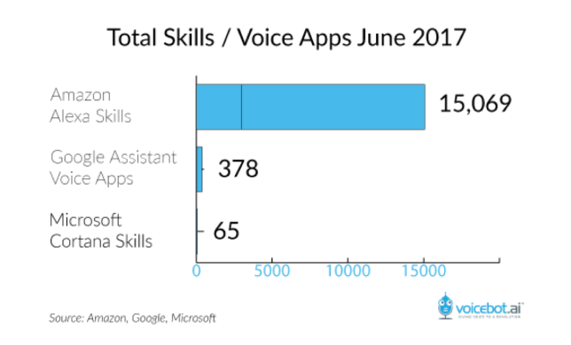
Figure3 The comparison between Alexa and its nearest competitors[5]
Alexa is now available on a growing number of devices, from smart watches and digital intercoms to high-tech speakers and more. Smart home brands like ecobee,Philips Hue, Nest, LG and iDevices announce Alexa compatibility. It's even heading outside the home: Both Ford and Volkswagen are bringing Alexa to their cars for hands-free commands.
3.2 Case Study 2: WordPress
WordPress is a free and open-source content management system (CMS), featured by a plugin architecture and a template system. To function, WordPress has to be installed on a web server, which would either be part of an Internet hosting service or a network host in its own right.
Themes
WordPress users may install and switch between different themes. Themes allow users to change the look and functionality of a WordPress website without altering the core code or site content. Every WordPress website requires at least one theme to be present and every theme should be designed using WordPress standards with structured PHP, valid HTML (HyperText Markup Language), and Cascading Style Sheets (CSS). The PHP, HTML and CSS found in themes can be directly modified to alter theme behavior, or a theme can be a "child" theme which inherits settings from another theme and selectively overrides features.[14] WordPress themes are generally classified into two categories: free and premium. Many free themes are listed in the WordPress theme directory, and premium themes are available for purchase from marketplaces and individual WordPress developers. WordPress users may also create and develop their own custom themes. The free theme Underscores created by the WordPress developers has become a popular basis for new themes.[15]
Plugins
WordPress' plugin architecture allows users to extend the features and functionality of a website or blog. Now, WordPress has over 50,316 plugins available,[16] each of which offers custom functions and features enabling users to tailor their sites to their specific needs. These customizations range from search engine optimization, to client portals used to display private information to logged in users, to content management systems, to content displaying features, such as the addition of widgetsand navigation bars. Most plugins are available through WordPress themselves. But many third parties offer plugins through their own websites, many of which are paid packages.
Because of these, WordPress was used by more than 27.5% of the top 10 million websites as of February 2017.[6] WordPress is reportedly the most popular website management or blogging system in use on the Web,[7] supporting more than 60 million websites.[8]
- Discussion
The Amazon Alexa is a typical platform ecosystem. The main players in the platform ecosystem are clear. The producers are the Alexa skills developers, the consumers are the Alexa compatible devices buyers, the owner of the platform is Amazon, the Alexa compatible devices are the platform providers.
While for WordPress, the producers are third party theme or plugin developers and the users who create and develop their own custom theme sor plugins, consumers are WordPress users, the owner is WordPress.org and the platform providers are web servers which WordPress installed on.
In comparison, Amazon Alexa belongs to the Integrator Platform model, because in terms of voice service, Alexa owns and controls the interactions with the end-users. While WordPress is more like two-sided platform model.
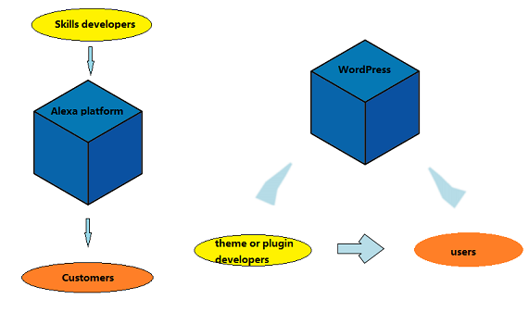
Figure4 Amazon Alexa and WordPress’s platform model (created by Lingzuo Zhao for INFO5992)
Amazon Alexa and WordPress use different platform model probably because they have different aims of using platform. For Amazon Alexa, its purpose is using this platform to dominate the internet of things(IoT) space, so that Amazon can gain tangible and intangible benefits through the platform. In contrast, WordPress is released under the GPLv2 (or later) license, and its purpose is to make WordPress more powerful by attracting talented developers and adopting user innovation, thus the two- sided platform model is more suitable.
Both Amazon Alexa and WordPress.org pursue the network effects and try to attract more participants. Amazon Alexa launches a venture capital fund program to funding startups utilizing Alexa and rewards developers who add skills to Alexa with money and free Amazon Web Services(AWS). And WordPress is free and open source which is a key element to attract users and innovators.

- Conclusion

The platform ecosystems set protocols to bring producers and consumers together and manage the interactions which benefits all participants. The platform ecosystem can be used to attract external innovators to bring innovations that conform to the platform owner’s marketing strategy and vision, so that it is an effective way to dominate the market and influence the parties involved in the industry. Amazon Alexa and WordPress are good cases of implementing platform strategy to achieve their purposes.

Reference
[1] John Hagel. (2015). The power of platforms. Retrieved from:
https://dupress.deloitte.com/dup-us-en/focus/business-trends/2015/platform-strategy-new-level-business-trends.html
- Marshall, W. V. A., et al. (2016). Pipelines, Platforms, and the New Rules of Strategy.Boston, Harvard Business Review: 1.
- Boudreau, K. and K. Lakhani (2009). "How to Manage Outside Innovation." MIT Sloan Management Review 50(4): 69.
- Why Alexa? Amazon company. Retrieved from: https://developer.amazon.com/alexa
- Amazon’s Alexa passes 15,000 skills, up from 10,000 in February. TechCrunch. Retrieved from: https://techcrunch.com/2017/07/03/amazons-alexa-passes-15000-skills-up-from-10000-in-february/

